- all over the imagery.

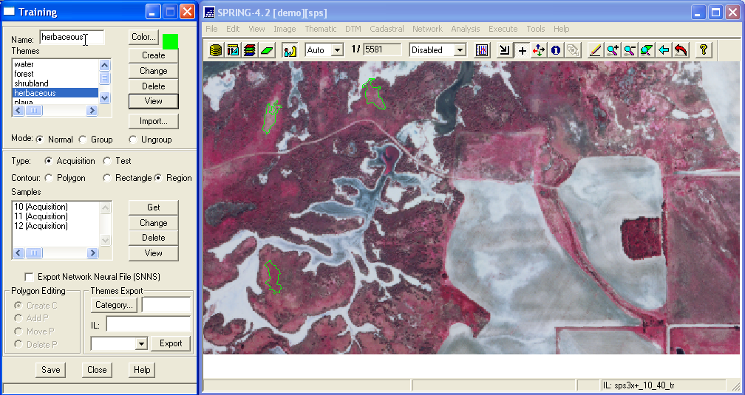

- At some point you may want to save an image of your samples. To do this you will need to create a Category to hold thematic data. Select File | Data Model. In the Name: box type themes, select the Thematic checkbox, click on Create, then Apply. It will appear that nothing has happened but the newly created Category will appear in the Control Panel as soon as you put something in it.
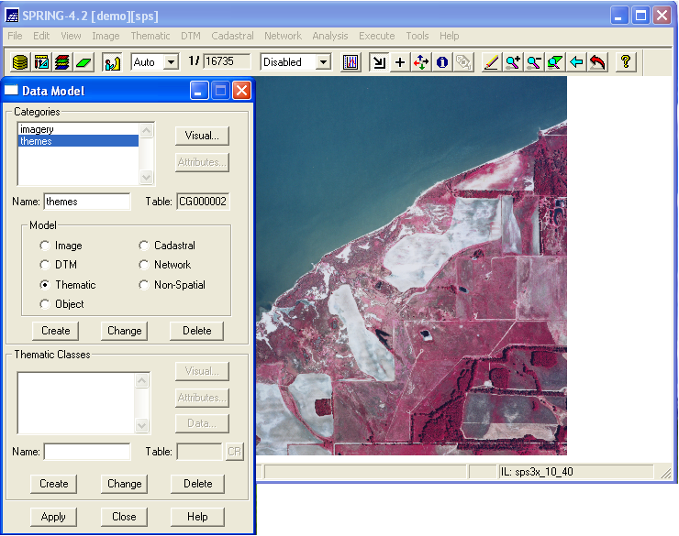

- Returning to the Training popup, near the bottom of the popup, under Themes Export, click on Category…. A Categories List popup should appear. Select the themes category you just created and click on Apply. Back in the Training popup, in the IL: box type sps3x_10_40_tr, making sure Acquisition appears in the window just below IL:, then click on the Export button. Maximize the Control Panel popup, highlight the themes Category, in the Infolayers window highlight the IL you just exported, click in the Classes checkbox, then click on Draw. All of your samples should appear.

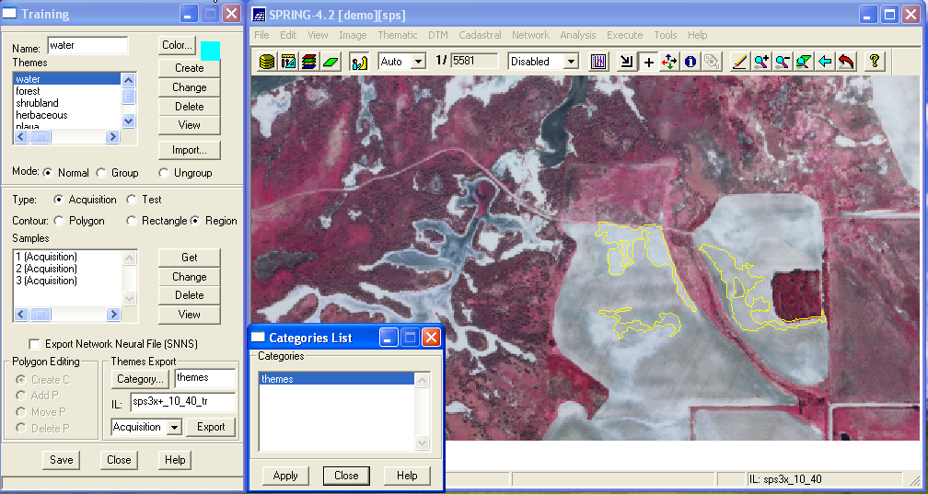

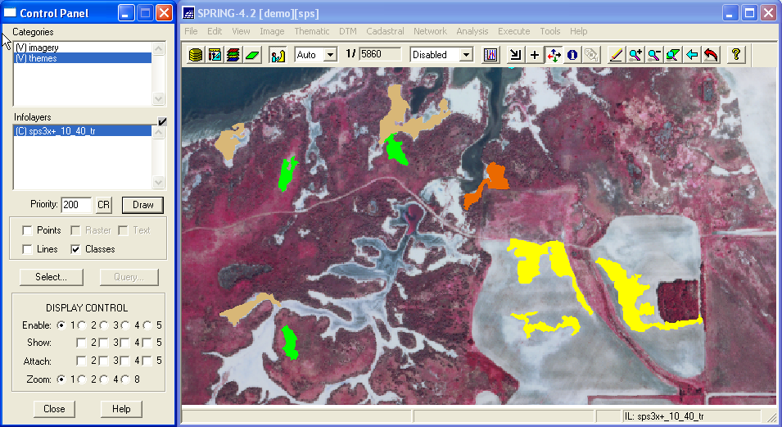

- As you select, Get, Save, and View your samples, you may want to occasionally export them, overwriting your themes Category. If something should go wrong, you can import the training samples by clicking on the Import button in the upper section of the Training popup, selecting the appropriate IL, then Apply.

2.7 Run Training Sample Analysis, Classification, and Output Map

- To make sure that your samples do not overlap, maximize the Classification popup, click on Classification, in the Name: box type sps3x_10_40_class, click on Create, in the Classifier: select Bhattacharya, Acceptance-Threshold: 99.9%, then click on the Sample Analysis button. A Sample Analysis popup should appear and will provide you with an accuracy assessment. If there are any questionable samples, you can easily find them by noting the theme, the sample number, returning to the Training popup, selecting the appropriate Theme and searching through the sample numbers. Highlight the suspect sample, click on View in the Samples section and locate, zoom to, and inspect the suspect sample. You can delete it and select, Get, Save, and View more samples.

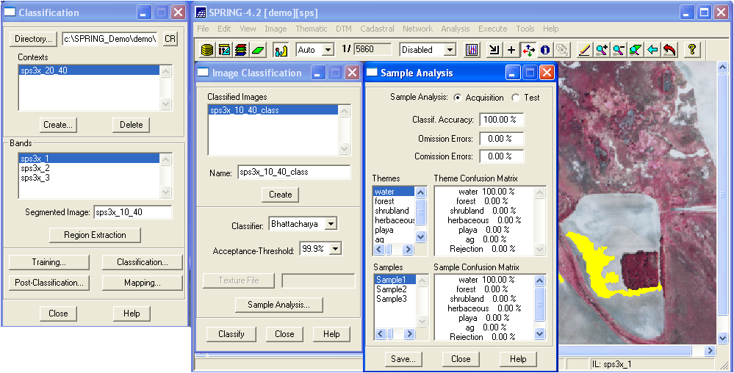

When you have gathered a few samples and tested for accuracy, run a classification. Maximize the Image Classification popup, highlight the classified image name you have been using to run the Sample Analysis or create a new one, under the Sample Analysis button, which you have been using, click on Classify. The classification should begin to run and will take up to a few hours on a large image. Once the classification has completed, a Notice will popup telling you exactly how long the classification took. This may prove handy in predicting how long various images will take to process for planning and scheduling purposes. Click on OK to close the Notice popup. Minimize the Classification popup. Minimize the Training popup. Minimize any other popups that may be in the way. Maximize the Control Panel popup. In the imagery

